**Task # 01: Create Simple Hello World! App Run on android virtual device and on your android phone.**

**XML FILE:**

<?xml version="1.0" encoding="utf-8"?>

<android.support.constraint.ConstraintLayout xmlns:android="http://schemas.android.com/apk/res/android"

xmlns:app="http://schemas.android.com/apk/res-auto"

xmlns:tools="http://schemas.android.com/tools"

android:layout_width="match_parent"

android:layout_height="match_parent"

tools:context=".MainActivity">

<Button

android:layout_width="wrap_content"

android:layout_height="wrap_content"

android:text="CLICK ME!"

android:onClick="btnOnClick"

app:layout_constraintBottom_toBottomOf="parent"

app:layout_constraintLeft_toLeftOf="parent"

app:layout_constraintRight_toRightOf="parent"

app:layout_constraintTop_toTopOf="parent" />

</android.support.constraint.ConstraintLayout>

**JAVA FILE:**

package com.example.myapplication;

import android.support.v7.app.AppCompatActivity;

import android.os.Bundle;

import android.view.View;

import android.widget.Toast;

import org.w3c.dom.Text;

import static android.app.ProgressDialog.show;

public class MainActivity extends AppCompatActivity {

@Override

protected void onCreate(Bundle savedInstanceState) {

super.onCreate(savedInstanceState);

setContentView(R.layout.activity_main);

}

public void btnOnClick(View v){

Toast.makeText(getApplicationContext(), "HELLO WORLD!", Toast.LENGTH_SHORT).show();

}

}

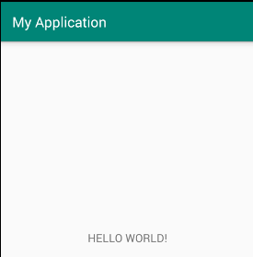

**Task # 02: Why we need separate folder for Assets and Resources if both folder are for same purpose?**

Both are quite similar. The real main difference between the two is that in the res directory each file is given a pre-compiled ID which can be accessed easily through R.id.[res id]. This is useful to quickly and easily access images, sounds, icons...

The assets directory is more like a filesystem and provides more freedom to put any file you would like in there. You then can access each of the files in that system as you would when accessing any file in any file system through Java. This directory is good for things such as game details, dictionaries,...etc

**Task # 03: Explain the directory structure of simple Hello World app created in task 1.**

